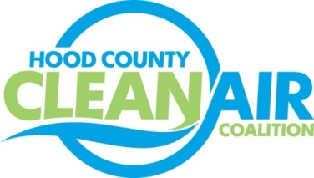
Meeting: Tuesday, May 5, 2015
American Town Hall
220 N. Travis Street, Granbury, Texas 76048
8:30-10:00 a.m.

Agenda

- Call Meeting to Order
- Local Updates – Michelle McKenzie
  - Review of Projects
    - Status of Projects
      - Proposed Promotion for Air Quality Program Manager – Executive Session
      - Bike Equipment
      - Propane Refueling Stations
      - Lawn Equipment Exchange
    - Monthly Budget Review for March
  - Rider 8 Contract Extension
  - Review of April Meeting Summary
  - Certificate of Formation
  - Reports
    - CenSARA Conference Call
    - Ozone Update
    - Earth Day Events
      - Earth Day Museum at Emma Roberson Elementary
      - Earth Day Event at Weatherford College Campus
  - Air North Texas Reminder: Clean Air Action Day – June 26
  - FY 16/17 PGA
- Regional Updates – Chris Klaus
  - Clean Fleet Policy Adoption Update
  - Funding Opportunities at www.nctcog.org/aqfunding
    - TERP Light Duty Motor Vehicle Purchase and Lease Incentive Program
    - TERP Rebate Grants Program
  - EPA Grant Funding expected soon – National Clean Diesel Funding Assistance Program
- EPA Updates – Michelle McKenzie
5.) Discussion
6.) Adjourn

